Collecting User Acquisition Data Through all Channels (2/26-3/5)

Website/SEO Assignments

NAME: Tahiya Rahman

horizontal line

# About the Data

The purpose of the paper is to find out the highest session used by the users and how many new users had been increased over the tie period. The analysis will depict through the visuals to understand the potential growth area within user acquisition data.

**Trend & Data**

The data shown as the glance of all the user acquisition along with other analytics which are user behavior and user conversion. The user acquisition data shows on the trendline which is considered to be a decent number.

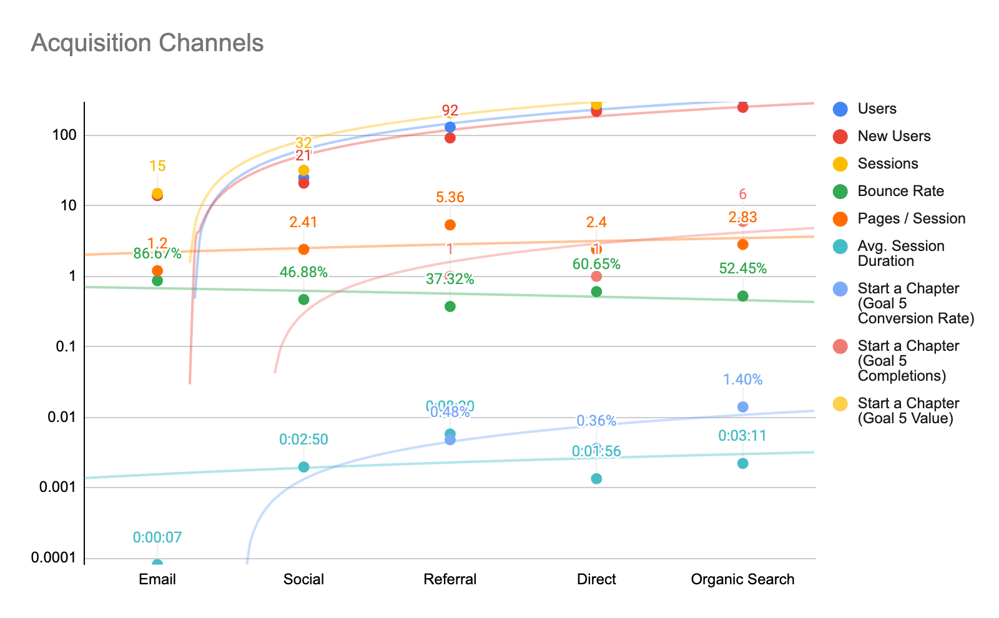

There is a correlation between all the user analytics and a clear drop with email marketing. Where email marketing has not shown any desirable outcome. The metric is under the trendline and being an under performer for the email marketing channel.

# What NSTEM Should Continue Doing

* NSTEM should continue focusing on the referral and keep creating good keywords for the google organic search.

# Ways to Improve the Website

* NSTEM should check and create a email marketing campaign/software tool
* Can create call to action button on the email to boring more traffic to the webpage

# Data that Stands Out

The organic search data stood out from all the data metrics. Because there showed a correlation between the user acquisition and user behavior analytics within the organic search which is positive and potential.

**Conclusion**

For the last week to March first week the data was reliable enough to create potential investment opportunities for the paid search to increase the target audience.

Google Sheets:

<https://docs.google.com/spreadsheets/d/1uOUhMsuTZxeVduIonjfD7HarZqfbDHPpr8nfwdj0Uec/edit?usp=sharing>